# Creating output file from script Results

Copy Script in one location

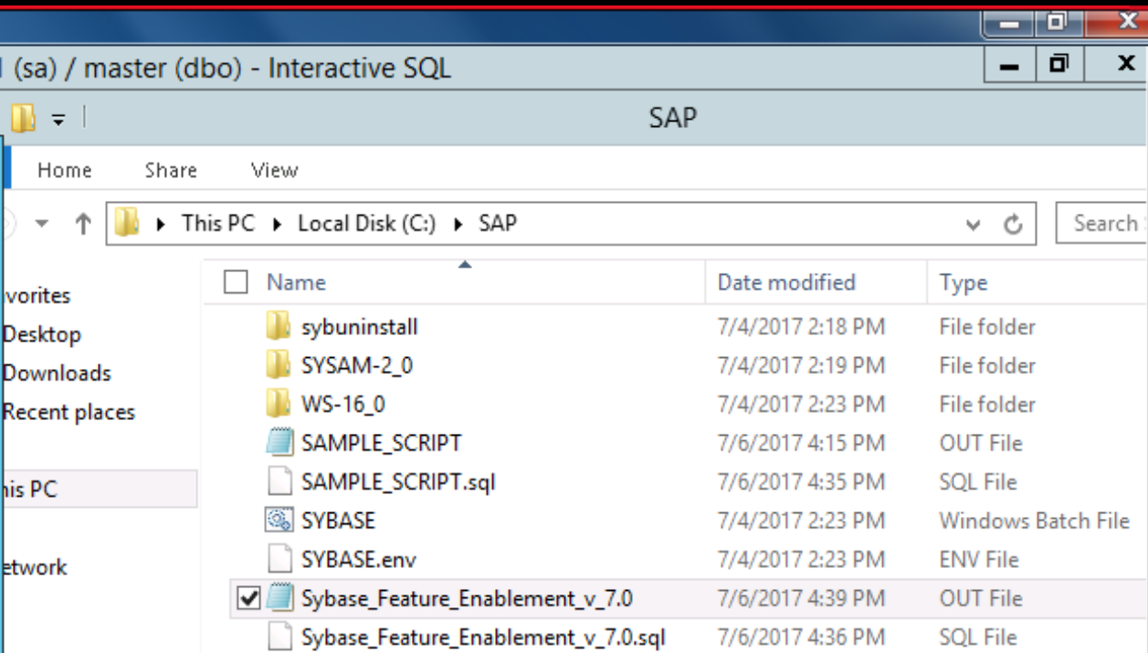

## Procedure

Go to CMD and execute the program after specifying the output file name as below in the picture.

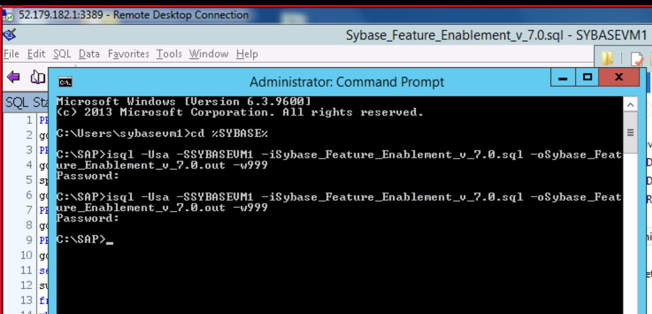

## Results

The result set is exported to the file that you specified. You can copy the file from the file system.